**1. Evolution of Banking Technology in the USA**

**2. Banking System Resilience During Economic Crises in the USA**

**(Presented By Alan Stuart K)**

**The Transformation of American Banking: A Report on the Evolution of Banking Technology in the USA**

**Introduction:**

The American banking system has undergone a remarkable transformation in recent decades. From the brick-and-mortar branch dominance of the past to the mobile-centric landscape of today, technology has fundamentally reshaped how we manage our money. This report delves into this evolution, exploring key milestones, the impact of technology, and emerging trends shaping the future of US banking.

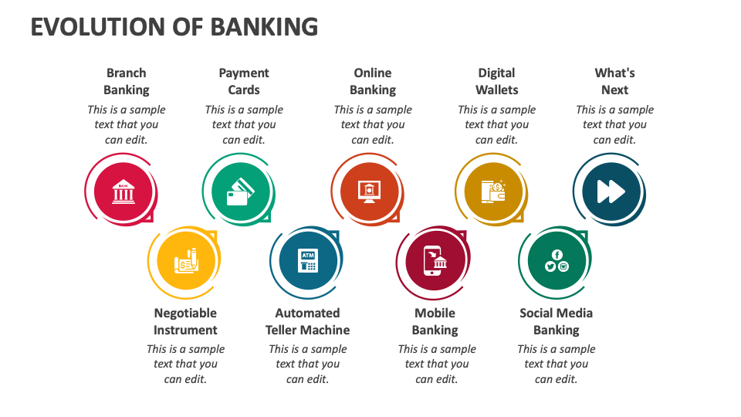

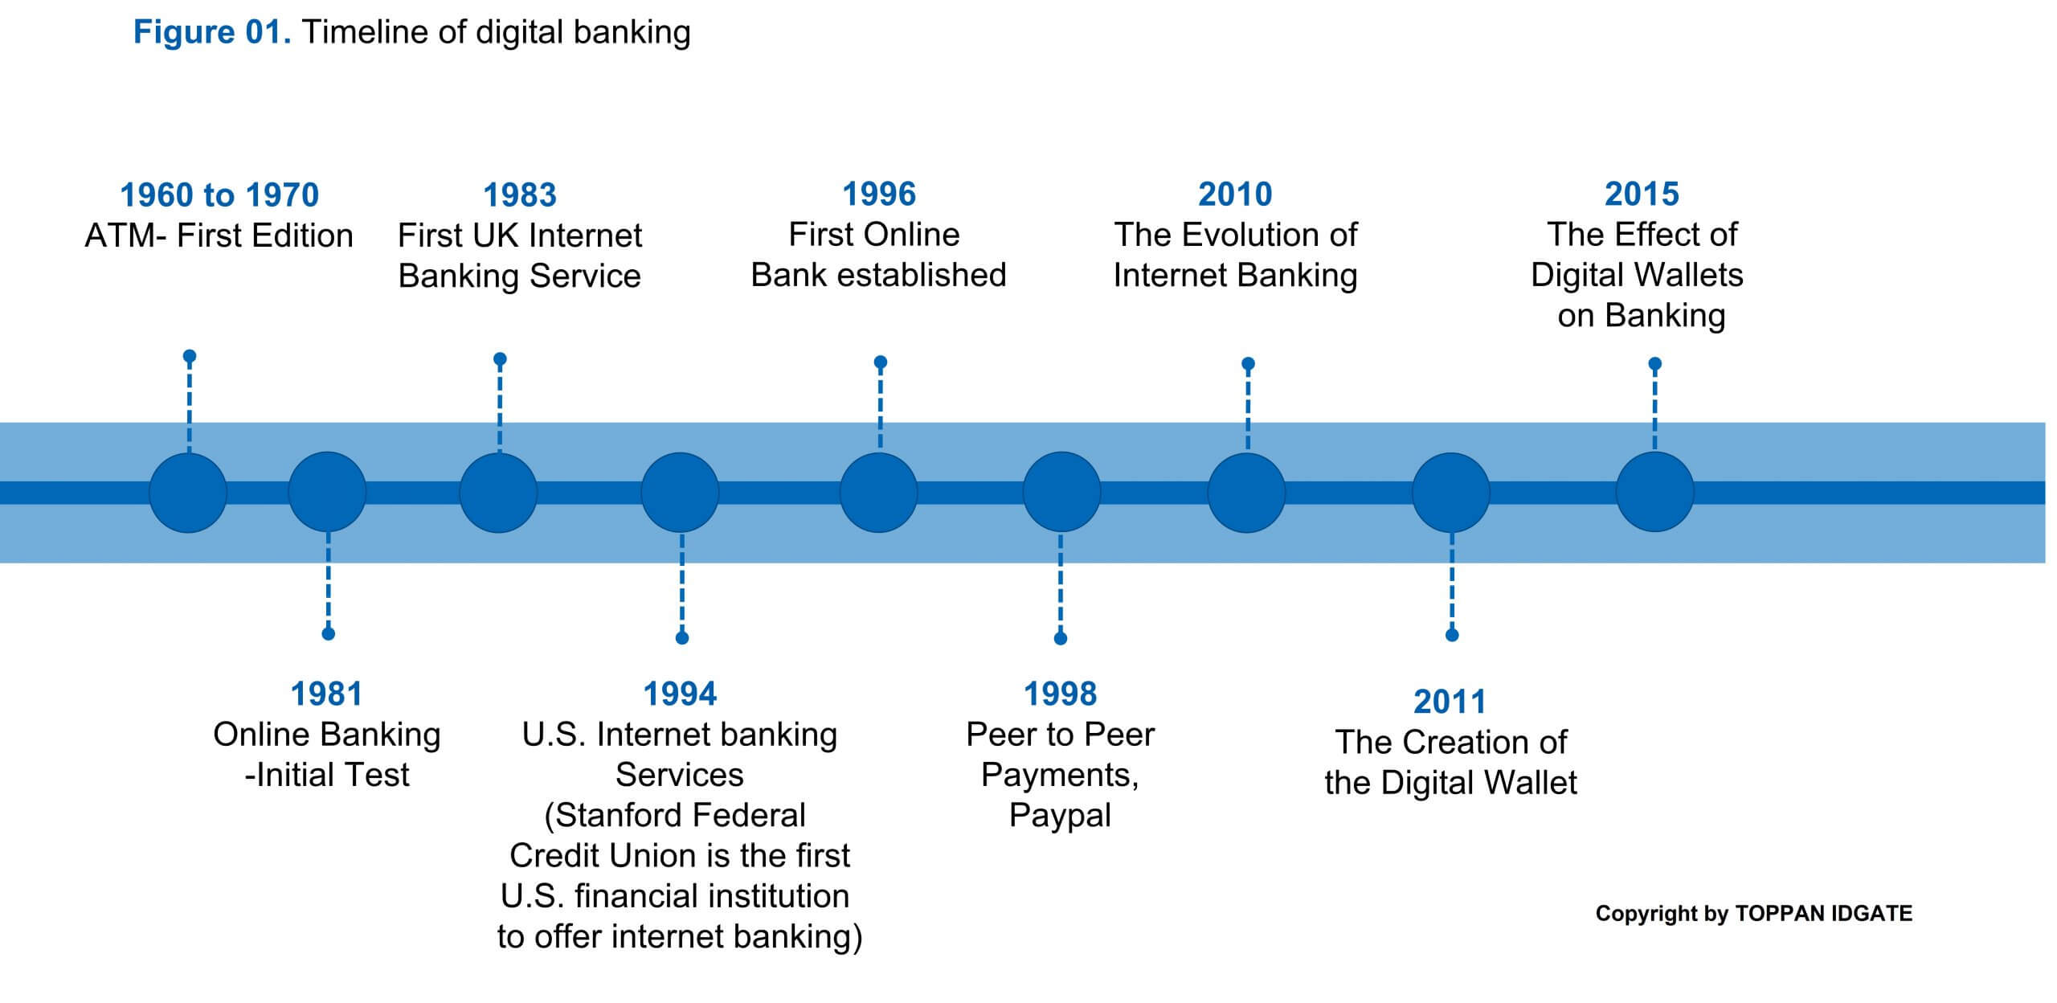

**Early Days: The Foundation (Pre-1950s):**

The roots of US banking technology can be traced back to the 18th century. Transactions were manual and time-consuming, relying on physical branches, handwritten ledgers, and paper checks. Customers interacted directly with bank tellers to deposit, withdraw, or transfer funds.

**The Automation Age (1950s-1980s):**

The mid-20th century ushered in a wave of automation. Punch card technology and mainframe computers facilitated basic automation of tasks like account management and check processing. This era also witnessed the invention of the magnetic stripe on credit cards in the 1960s, paving the way for:

* **Automated Teller Machines (ATMs):** Introduced in the 1970s, ATMs revolutionized access to cash, offering 24/7 withdrawals and basic account inquiries.

**Data for Consideration:**

According to a study by the Federal Reserve Bank of St. Louis, the number of ATMs in the US grew from a mere 100 in 1969 to over 400,000 by 2018. This exponential growth highlights the significant impact of ATMs on banking convenience.

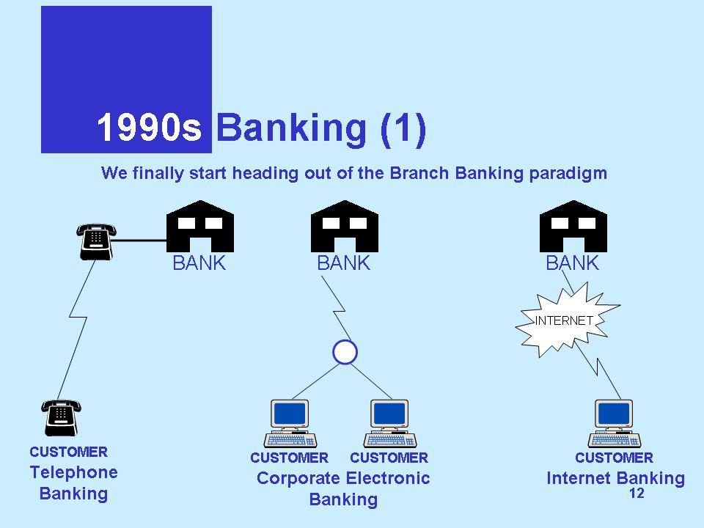

**The Dawn of Digital Banking (1990s-2000s):**

The 1990s saw the widespread adoption of personal computers, laying the groundwork for online banking. This era witnessed:

* **Rise of Online Banking:** Online banking platforms allowed customers to view account information and transfer funds electronically, offering greater flexibility and convenience compared to traditional branch visits.
* **The Internet Boom:** The late 1990s saw a surge in online banking adoption, fuelled by improved internet security protocols and user-friendly interfaces.

**Data for Consideration:**

A report by the Federal Deposit Insurance Corporation (FDIC) indicates that in 2000, only 16% of US households used online banking. By 2022, this figure had skyrocketed to 87%, showcasing the dramatic rise of online banking usage.

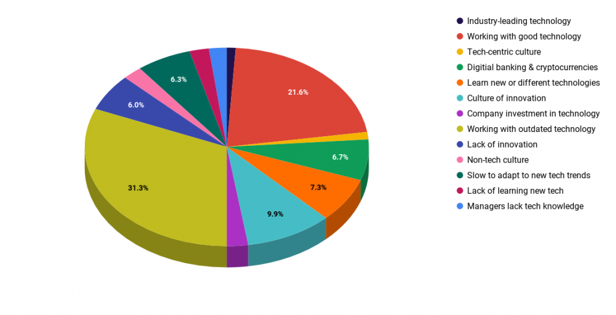

**The Mobile Banking Revolution (2000s-Present):**

The early 2000s witnessed the rise of smartphones, leading to:

* **Mobile Banking Apps:** The development of mobile banking apps transformed how people manage their finances. Users could now check balances, transfer funds, pay bills, and deposit checks – all from the convenience of their smartphones.
* **Big Data and Analytics:** Banks began leveraging big data and analytics to personalize financial products, detect fraud, and offer targeted financial advice.

**Data for Consideration:**

A study by Statista projects that the number of mobile banking users in the US will reach over 230 million by 2025. This data underlines the dominance of mobile banking in the modern financial landscape.

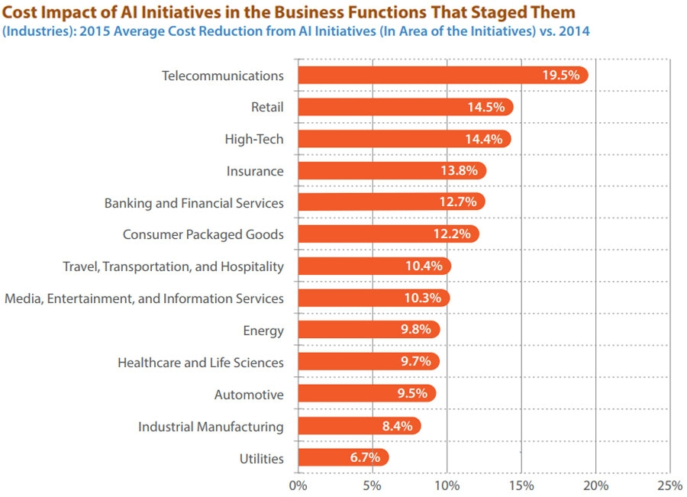

**The Impact of Technological Transformation:**

The evolution of banking technology has significantly impacted the US financial system:

* **Increased Convenience:** Customers now have 24/7 access to their finances, enabling them to manage their money on their own terms.
* **Enhanced Security:** Technological advancements like encryption and multi-factor authentication have improved the security of financial transactions.
* **Financial Inclusion:** Technology has made banking services more accessible to a wider range of people, including those in remote locations.
* **Competition and Innovation:** FinTech companies have emerged, challenging traditional banks and driving innovation in the financial services industry.

**Challenges and Considerations:**

Despite the benefits, technological advancements also present challenges:

* **Cybersecurity Threats:** As technology advances, so do cyber threats. Banks need to continuously invest in robust security measures to protect customer data.
* **The Digital Divide:** Not everyone has access to reliable internet or smartphones, which can create a digital divide and limit access to these financial services.
* **Regulation and Compliance:** Regulatory frameworks need to adapt to keep pace with technological advancements while ensuring consumer protection.

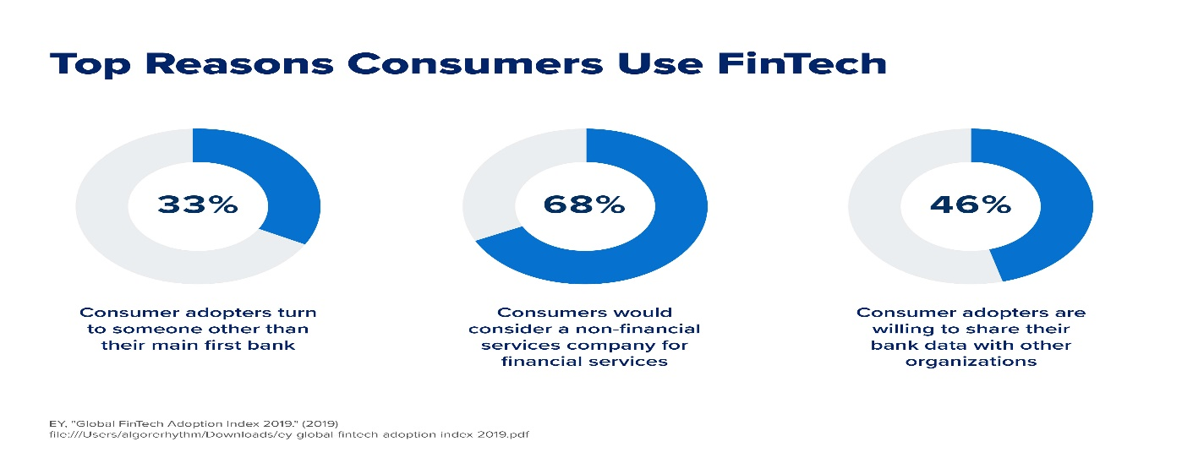

**Emerging Trends Shaping the Future:**

Looking ahead, several trends will likely define the future of US banking technology:

1. **Artificial Intelligence (AI) and Machine Learning (ML):** AI can personalize financial services, enhance customer service through chatbots, and automate tasks like loan processing.
2. **Open Banking and APIs:** Open Banking allows third-party FinTech companies to access customer data (with permission
3. **Blockchain Technology:** Blockchain offers a secure and transparent way to record financial transactions, potentially revolutionizing areas like cross-border payments and trade finance.
4. **The Rise of Cloud Computing:** Cloud computing allows banks to scale their IT infrastructure efficiently and potentially reduce costs.

**The Road Ahead: A More Personalized and Frictionless Banking Experience:**

These trends point towards a future where banking becomes even more:

* **Personalized:** AI can analyse customer data to offer tailored financial products, budgeting tools, and proactive solutions.
* **Convenient:** Biometric authentication (fingerprint, facial recognition) could enable secure and seamless payments without physical cards or codes.
* **Frictionless:** AI-powered tools could analyse spending patterns and provide personalized budgeting and saving recommendations.

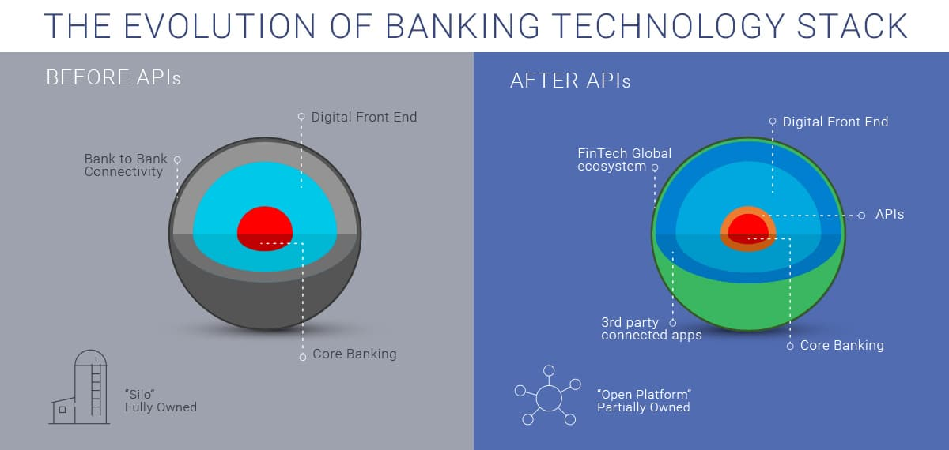

**Conclusion: A Symbiotic Future:**

The future of US banking technology lies in a symbiotic relationship between humans and machines. Technology will streamline processes and personalize services, while human expertise will ensure trust, provide guidance, and navigate the complexities of personal finance. This collaboration will shape a future where banking is not just efficient and convenient, but also supportive and empowering for all.

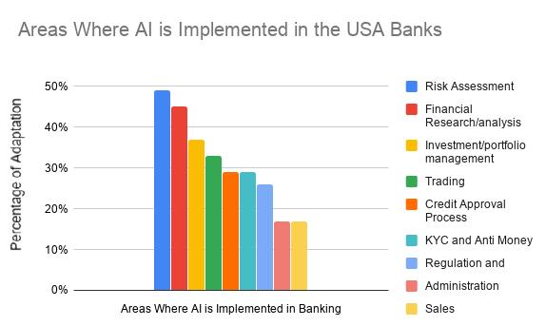

**Banking System Resilience During Economic Crises in the USA: A Report**

**Introduction:**

The resilience of the US banking system plays a critical role in mitigating the severity of economic downturns. A healthy and stable banking system can provide essential financial services, promote economic growth, and prevent financial crises from spiralling into deeper depressions. This report examines the evolution of US banking regulations and practices in the context of economic crises, focusing on how these measures have contributed to a more resilient banking system.

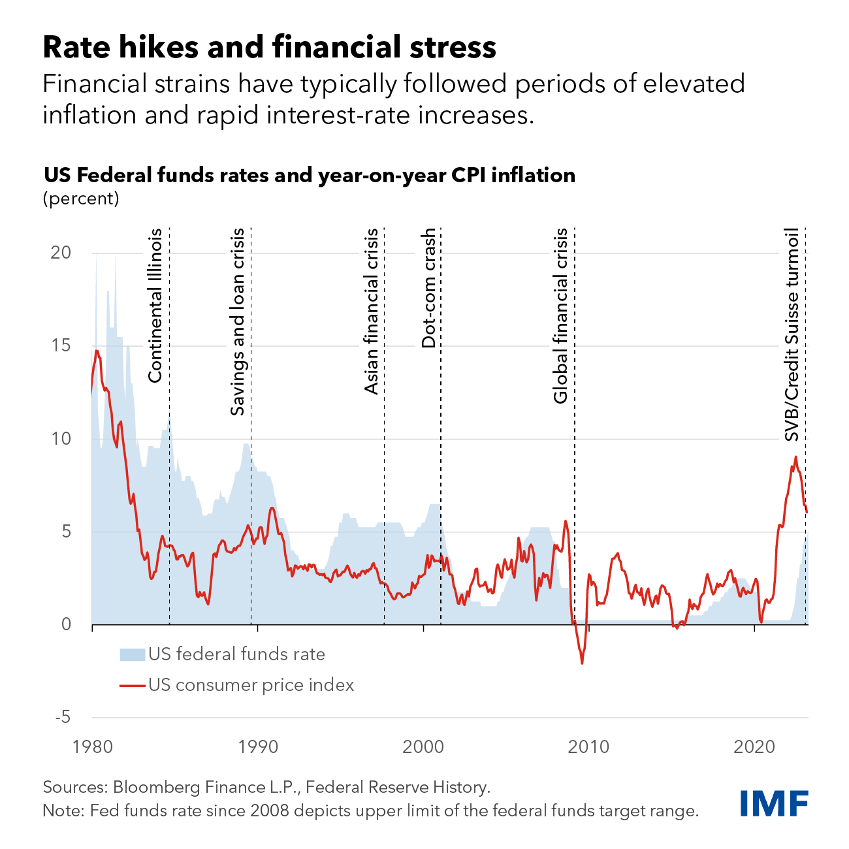

**Historical Perspective: Lessons Learned:**

* **The Great Depression (1929-1939):** This devastating economic downturn exposed weaknesses in the US banking system. Unregulated speculation, inadequate capital reserves, and interconnectedness among banks led to a wave of bank failures, severely disrupting the flow of credit and exacerbating the crisis.

**Data Point:** Between 1929 and 1933, over 11,000 banks failed in the US, wiping out billions of dollars in deposits.

* **The Great Recession (2007-2009):** The collapse of the housing market and subsequent financial crisis highlighted new vulnerabilities. Overly complex financial instruments, lax lending standards, and a lack of transparency in the mortgage market contributed to the crisis.

**Data Point:** The failure of major financial institutions like Lehman Brothers further eroded confidence in the financial system, leading to a sharp decline in lending and economic activity.

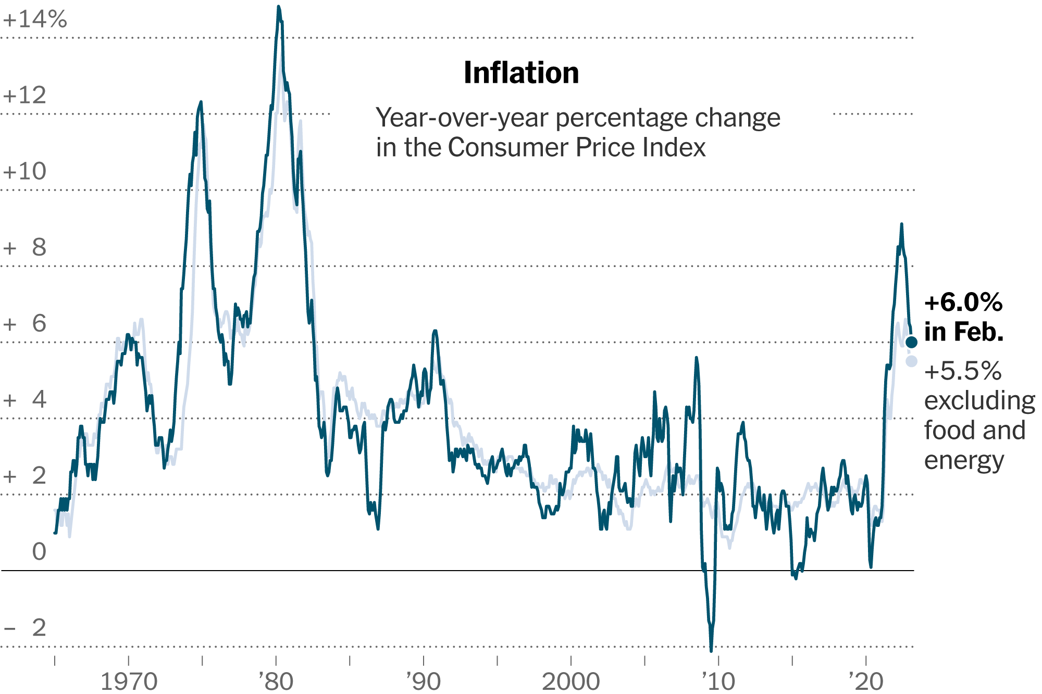

**The Response: Regulatory Reforms and Enhanced Supervision:**

Following these crises, policymakers implemented significant reforms aimed at strengthening the resilience of the US banking system:

* **The Dodd-Frank Wall Street Reform and Consumer Protection Act (2010):** This landmark legislation introduced stricter capital requirements for banks, created the Consumer Financial Protection Bureau (CFPB), and aimed to prevent excessive risk-taking.
* **Stress Testing:** Regulatory bodies like the Federal Reserve conduct regular stress tests to assess how banks would weather various economic scenarios. This helps identify potential vulnerabilities and prompt corrective actions.
* **Resolution Planning:** The creation of the Federal Deposit Insurance Corporation (FDIC) Orderly Liquidation Authority allows for a more orderly resolution of failing banks, minimizing disruptions to the financial system.

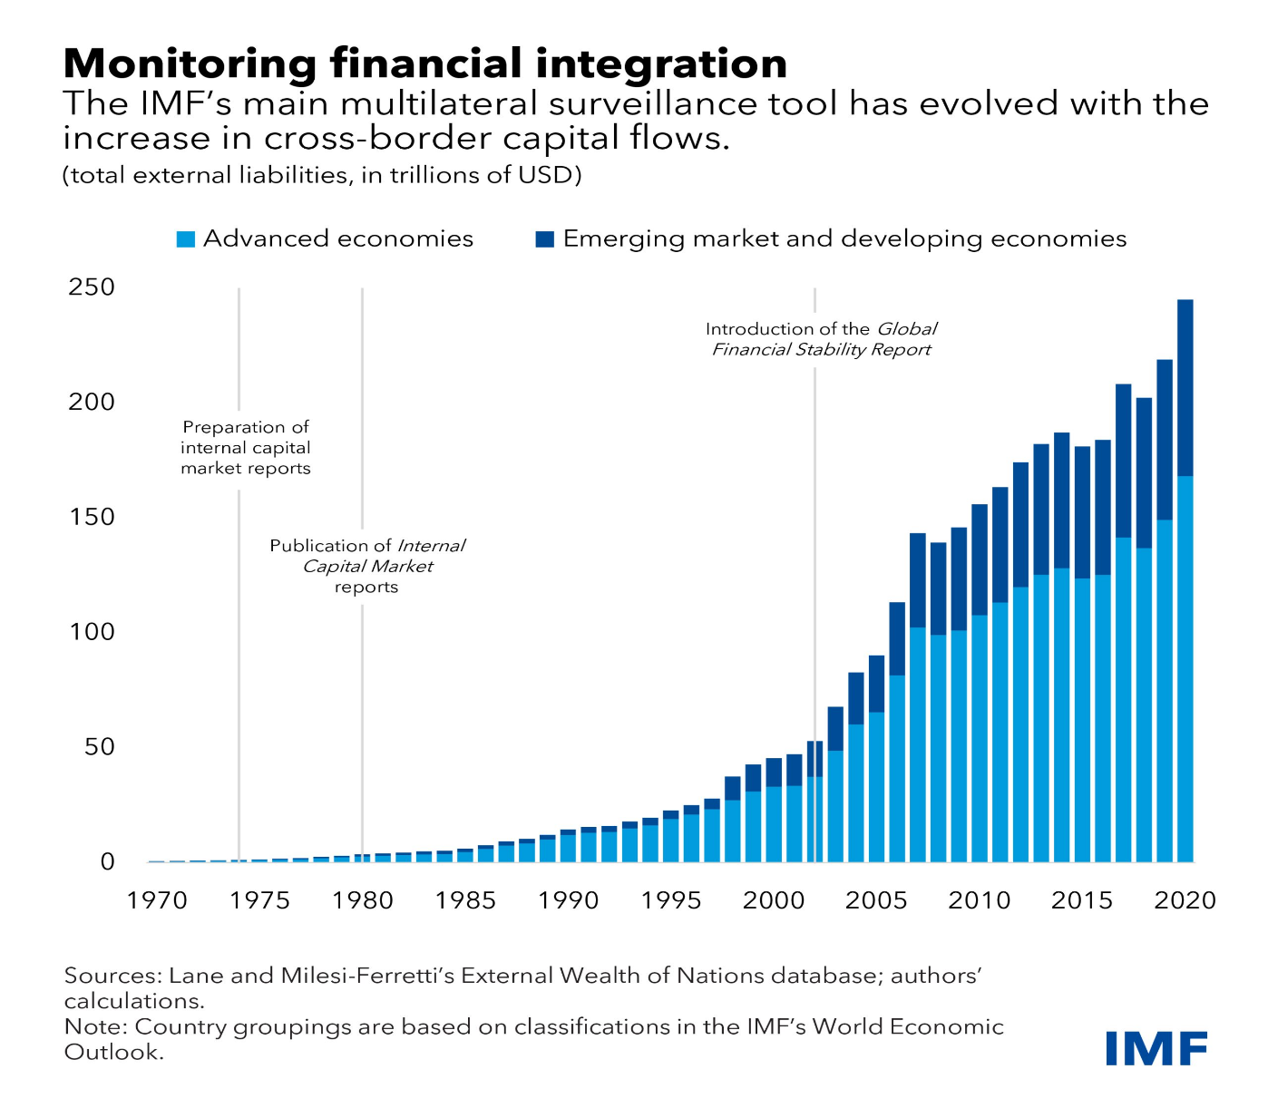

**The Impact of Reforms: Evidence of Increased Resilience:**

The reforms implemented after the Great Recession appear to have contributed to a more resilient banking system:

* **Stronger Capital Positions:** Since the crisis, US banks have maintained significantly higher capital levels, providing a buffer to absorb losses during economic downturns.

**Data Point:** The average Tier 1 capital ratio (a measure of a bank's financial strength) for US banks stood at around 13.5% in 2023, compared to just 10% in 2007 [3].

* **Improved Liquidity Management:** Banks are now required to maintain higher levels of liquid assets, allowing them to meet withdrawal demands and continue lending activities during periods of stress.
* **Enhanced Regulatory Oversight:** Regular stress testing and stricter supervision by regulatory bodies help identify and address potential risks before they escalate.

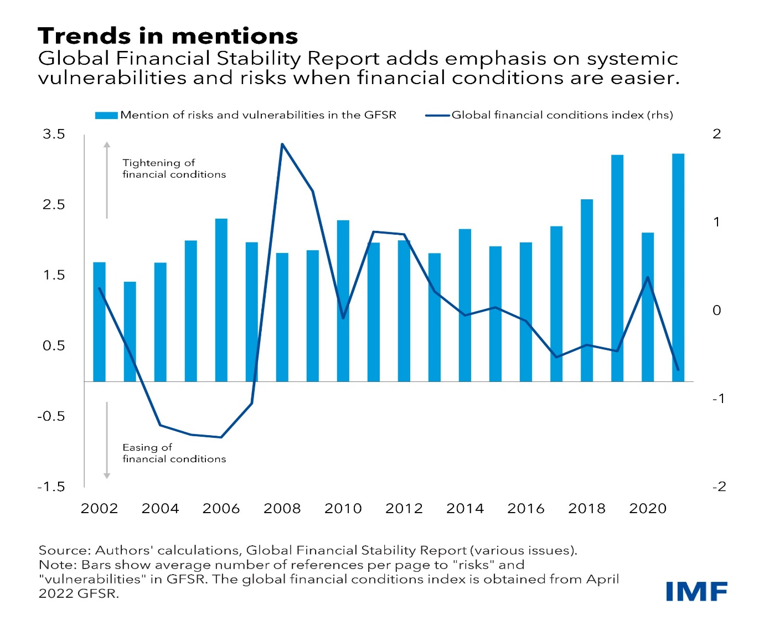

**Case Study: The COVID-19 Pandemic (2020-Present):**

The COVID-19 pandemic presented a unique challenge for the US banking system. Lockdowns and economic disruptions threatened to trigger another financial crisis. However, the strengthened regulatory framework helped the banking system weather the storm:

* **Government Intervention:** The CARES Act provided significant financial assistance to businesses and households, helping to stabilize the economy and prevent widespread loan defaults.
* **Bank Lending Programs:** The Pay check Protection Program (PPP) provided loans to small businesses, helping them retain employees and stay afloat during the pandemic.
* **Deferment Programs:** Many banks offered loan forbearance and deferment programs to borrowers experiencing financial hardship due to the pandemic.

**While the full economic impact of the pandemic is still unfolding, evidence suggests that the US banking system was better equipped to handle this crisis compared to previous ones.**

**Challenges and Considerations:**

Despite the progress made, there are ongoing challenges to maintaining a resilient banking system:

* **Cybersecurity Threats:** Cyberattacks pose a significant threat to financial institutions, and robust cybersecurity measures are essential.
* **Climate Change Risks:** The potential financial impact of climate change events like extreme weather needs to be factored into risk assessments.
* **Income Inequality:** The growing wealth gap could increase the vulnerability of certain segments of the population during economic downturns.

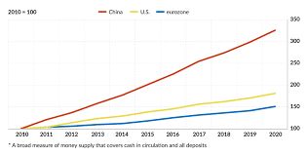

**The Road Ahead: Building on a Stronger Foundation:**

Looking ahead, continued efforts are necessary to ensure a resilient US banking system:

* **Adapting Regulations:** Regulations need to evolve to keep pace with technological advancements and new economic challenges.
* **Promoting Financial Inclusion:** Efforts to expand access to financial services can help build a more inclusive and resilient financial system.
* **Cybersecurity Investments:** Continuous investment in cybersecurity measures is crucial to protect
* **Cybersecurity Investments:** Continuous investment in cybersecurity measures is crucial to protect financial institutions and consumers from cyberattacks.
* **International Cooperation:** Collaboration with international regulatory bodies is essential to address global financial risks and ensure a stable global financial system.

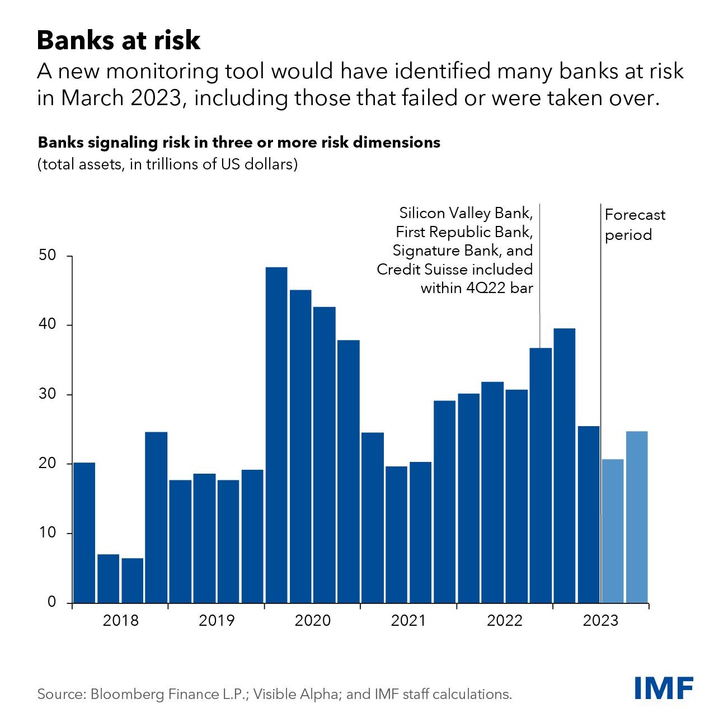

**Conclusion:**

The US banking system has come a long way in terms of resilience since the Great Depression. Regulatory reforms, enhanced supervision, and a stronger capital base have all contributed to a more stable financial system. However, maintaining this resilience requires continued efforts to address emerging challenges like cybersecurity threats and climate change risks. By building on the lessons learned from past crises and adapting to new ones, the US can ensure a banking system that weathers economic downturns and supports continued economic growth and prosperity.

